Dear _______:

As our community and our world strives to get back to normal, I see that we are making great progress. That’s what keeps me as a business owner, community servant, mother and wife hopeful – progress.

On-Going Challenges
While we are making great strides in so many areas of our community, here at absolutely! focus media – like many of you – we are still facing challenges. As you have likely noticed, the paper that we have been printing on for the past few months has not been reflective of the quality that our advertisers and readers are accustomed to. The supply chain issue regarding paper has hit us hard, and we have been forced to print on paper that is frankly not up to our standards. Our paper costs have increased over 40%, our printing time has increased by nearly 50% and our fulfillment costs have increased, significantly impacting delivery. Basically, we are paying much more for much less, and the quality is not in keeping with our company’s mission.

The Future
The good news is we were prepared. Over the past year, we have significantly increased our digital footprint by launching multiple campaigns to increase our website views, social media followers and our digital subscriber base. The best news of all? It’s working.

In 2022, we will bring you the people, places and more of the happenings than ever before with our new eZines – Fort Bend Focus, absolutely! Brazos and absolutely! Katy – digital versions of our award-winning community magazines. And yes, our subscriptions will remain free to our community along with all content being available on all of our websites and our Facebook pages.

eZines
Our new digital format will provide our valued advertisers more opportunities and exposure than ever before. Our new eZine Advertising Campaign options include:
Digital Issues E-Mailed Twice Monthly to Subscribers
Digital Ads Click Thru to Advertiser Websites
Digital Issues Posted Twice Monthly on Social Media
Timely Community Calendar Updates • On-Line Digital Issues
Web Ads • Videos • Event Posts • QR Code Lobby Distribution
Social Media Endorsements & Contests • Advertiser Directories with Web Links on Magazine Websites

Community Partners
While our digital presence will be significant, we will be out and about more than ever before to bring our readers timely community news. We remain your community magazine – your community partner – in growing your business in an even greater targeted approach. We look forward to continuing to come into your homes via your computers, tablets and cell phones much more than once a month with the news you need and want to know about your community.
Our goal is to continue our valued partnership with you to make 2022 the best year ever for our businesses and our community. Questions? Please reach out. We are here to help.

As always, stay focused!
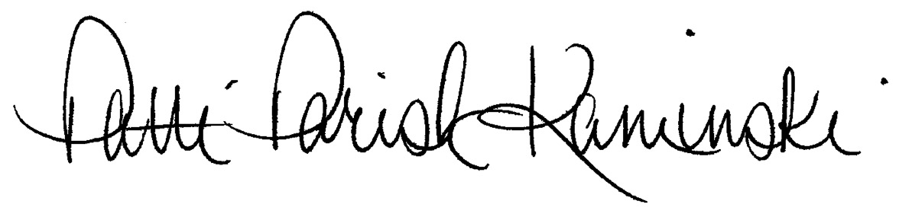
Patti A. Parish-Kaminski, patti@absolutelyfocusmedia.com
Publisher, absolutely! focus media

